Decision Tree
- Data Preparation:
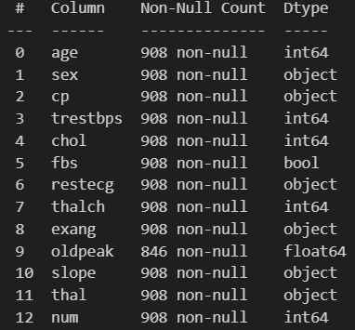
2. Exploratory Data Analysis (EDA):
Check for missing values, outliers, and inconsistencies in the data.
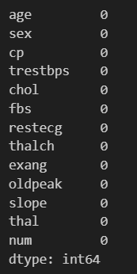
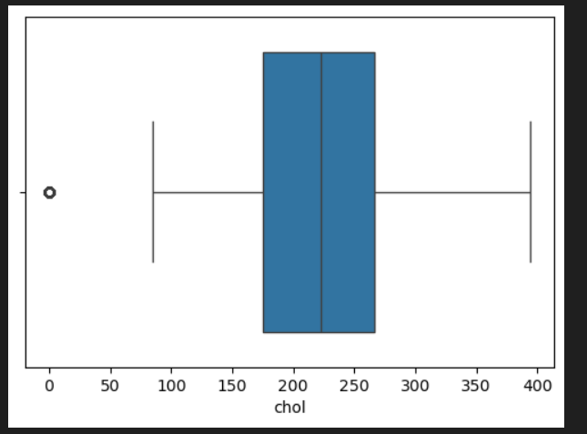
Insights from Box Plot
- Outliers:
The chol (cholesterol) feature has significant outliers, with values exceeding 600.
trestbps (resting blood pressure) also has some outliers but to a lesser extent.
oldpeak and fbs show minimal variations.
- Feature Scaling:
Since Decision Trees are not sensitive to feature scaling, normalization is optional.
However, handling extreme outliers may help improve model stability.
Insights from Correlation Matrix
- Moderate Correlations:
oldpeak has a moderate correlation with num (target variable), which suggests it may be an important predictor.age and num also have some correlation (0.33).
- Low Correlation:
chol, fbs, and trestbps show weak correlations with num, which suggests they may be less influential in predicting heart disease.

- Decision Tree Classification:
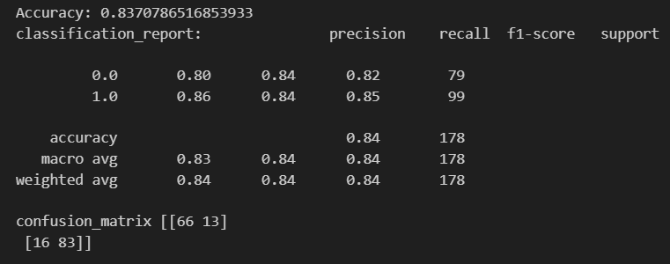
- Good accuracy (83%), but poor recall and precision for minority classes.

6. Model Evaluation and Analysis:
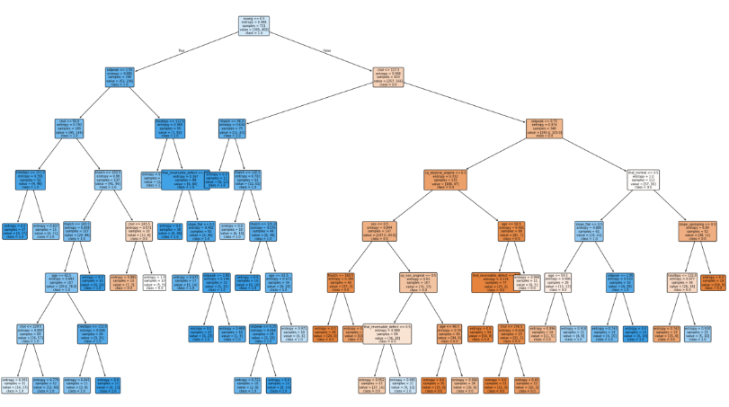

Insights & Model Performance Issues:
Good Splitting Criteria: The tree selects medically relevant features
Imbalanced Classification: Many leaf nodes favor "No Disease," which aligns with the previous classification report issues (low recall for disease detection).
Possible Overfitting: Deep tree structure with small sample sizes in some nodes suggests that pruning or limiting tree depth might improve generalization.

